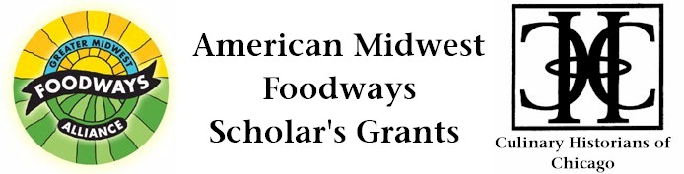

Culinary Historians of Chicago
280 Laurel Avenue

Highland Park, IL 60035
Contact: Catherine Lambrecht
Day/evening: 847/432-8255
e-mail: CulinaryHistorians@gmail.com

American Midwest Foodways Scholar’s Grant
Oak Park, IL ---- Greater Midwest Foodways Alliance, in collaboration with Culinary Historians of Chicago and with funding from the Julia Child Foundation for Gastronomy and the Culinary Arts, is pleased to announce financial support for the study of Midwestern foods and food-related institutions.
This support is offered as three American Midwest Foodways Scholar’s Grants: one grant is for $3,000, a second is $1,500, and a third is $500. Each is intended to help underwrite the research of academics and other investigators who intend to publish their findings in books, articles, videos or other media.
The grants are merit based and unrestricted. They can be used to support fieldwork, library visits, conference attendance, or any other activities related to the applicant's proposed project.
The American Midwest Foodways Scholar’s Grant is open to all individuals age 18 and older. Affiliation with an academic institution is not required, although students and others affiliated with such institutions are encouraged to apply. In selecting a recipient of the American Midwest Foodways Scholar’s Grant, the Greater Midwest Foodways Alliance and Culinary Historians of Chicago do not discriminate on the basis of race, gender, religion or national origin.
The Greater Midwest Foodways Alliance and Culinary Historians of Chicago would like to increase the amount or number of grants given in the future and contributions to the scholarship fund are encouraged.
Additional information and application can be found at www.GreaterMidwestFoodways.com. Any queries, please contact Catherine Lambrecht at CulinaryHistorians@gmail.com and telephone: 312/380-1665.
Greater Midwest Foodways Alliance is dedicated to celebrating, exploring and preserving unique food traditions and their cultural contexts in the American Midwest. By hosting public events, developing archival resources and generating publications, the Greater Midwest Foodways Alliance uncovers the distinctiveness of a region that is as varied in tastes and traditions as it is in its geography from the Great Lakes to the Great Plains. Whether indigenous foods such as Wisconsin cranberries and Minnesota walleye, iconographic flavors such as wheat and corn from across the prairies, immigrant cuisines from early Europeans to 21st century newcomers, or fish boils and fine dining in small towns and big cities, the Greater Midwest Foodways promotes and chronicles the diversity of the region's culinary character.
###

