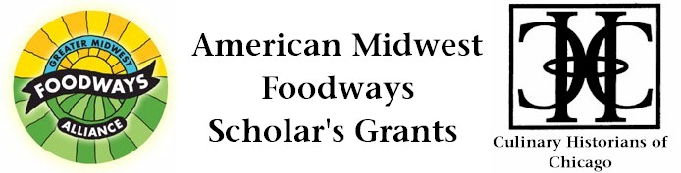

Greater Midwest Foodways Alliance in collaboration with Culinary Historians of Chicago and with funding from the Julia Child Foundation for Gastronomy and the Culinary Arts is pleased to announce financial support for the study of Midwestern foods and food-related institutions. This support is offered as three American Midwest Foodways Scholar's Grants: One grant is for $3,000, a second is $1,500, and a third is $500. Each is intended to help underwrite the research of academics and other investigators who intend to publish their findings in books, articles, videos or other media. The awards are merit based and unrestricted. They can be used to support fieldwork, library visits, conference attendance, or other activities related to the applicant's proposed project. Applicants specify the level of funding for which they wish to apply. However, the committee, at its discretion, will choose the level of grant to make in its individual awards, i.e. a request for a larger amount may receive a lesser sum.
Instructions and Grant Application
There Are Five Parts To The Application For The American Midwest Foodways Scholar's Grant:
(1) An unsigned essay of up to 500 words detailing the project for which the American Midwest Foodways Scholar's Grant is sought;

(2) A budget showing how the money is to be used and why the requested sum is needed;

(3) A letter of recommendation from an individual familiar with the applicant's work in food studies (single original);

(4) A résumé or CV (single original);

(5) A completed application and release (single original).

In the Unsigned Essay the applicant should describe, in detail, the project for which the grant is sought and its projected contribution to food studies. Creativity and scholarship are the main criteria by which projects will be evaluated.

The Unsigned Essay evaluation will be blind -- that is, the judging committee members will not be able to identify the author of the essay. Do not sign the essay, but do include the working title you provided on the Application Form and Release.

Applications and supporting documentation must be postmarked no later than April 1, 2013 and may be sent by e-mail to CulinaryHistorians@gmail.com and by U.S. First Class Mail (i.e. not via registered or certified mail) to:

Culinary Historians of Chicago

Attn: Scholar's Grant Committee
280 Laurel Avenue
Highland Park, IL 60035-2620

Fine Print
If you would like confirmation your application was received, please contact us by email. It is anticipated the recipient will be announced on or before April 20, 2013, with the funds disbursed soon thereafter. The winner will be a featured speaker at a Culinary Historians of Chicago or Greater Midwest Foodways Alliance meeting during the 2013-14 period to share the fruits of the funded research.

The American Midwest Foodways Scholar’s Grant is open to all individuals age 18 and older. Affiliation with an academic institution is not required, although students and others affiliated with such institutions are encouraged to apply. In selecting a recipient of the American Midwest Foodways Scholar’s Grant, the Greater Midwest Foodways Alliance and Culinary Historians of Chicago do not discriminate on the basis of race, gender, religion or national origin.

The committee reserves the right not to award the grant if, in its sole judgment, none of the projects submitted for its consideration is appropriate for American Midwest Foodways Scholar’s Grant sponsorship. The decision of the committee is final. By applying for the American Midwest Foodways Scholar’s Grant, the applicant expressly agrees that Greater Midwest Foodways Alliance or Culinary Historians of Chicago assumes no financial obligation to any person, institution or creditor of the recipient. Greater Midwest Foodways Alliance and Culinary Historians of Chicago reserves the right to a refund of the American Midwest Foodways Scholar’s Grant if the recipient fails to conduct the project for which the grant was awarded.

Contributions to American Midwest Scholar's Grant Fund
The Greater Midwest Foodways Alliance and Culinary Historians of Chicago would like to increase the amount or number of grants given in the future. Contributions to the fund are encouraged. Further information is available by contacting us.

The Greater Midwest Foodways Alliance is a tax-exempt organization under § 501(c)3 of the Internal Revenue Code. Please consult your tax advisor for advice on the tax deductibility of contributions.

Any queries, please contact Catherine Lambrecht at GreaterMidwestFoodways@gmail.com and telephone: 312/380-1665 or consult our website: www.GreaterMidwestFoodways.com
