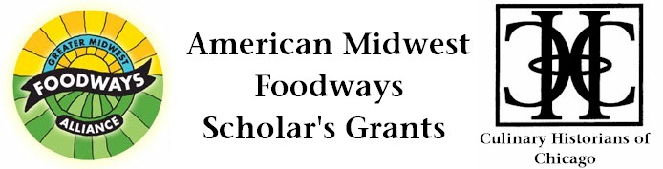
APPLICATION FORM AND RELEASE

Name: ________________________________________________________________________

Mailing Address: _______________________________________________________________

______________________________________________________________________________

Telephone_______________________ E-Mail _______________________________________

Project Working Title: ___________________________________________________________
(Please also provide this Project Working Title on your Unsigned Essay.)

I agree that, if I am the recipient of a 2013 American Midwest Foodways Scholar’s Grant (grant), and as a condition of my acceptance of the grant, I will present an hour-long program based upon the project to either Greater Midwest Foodways Alliance or Culinary Historians of Chicago during the 2014–2015 program year. I will receive no compensation for the program and will bear any necessary expenses for travel in connection with the program. Greater Midwest Foodways Alliance and Culinary Historians of Chicago will use all best efforts to schedule the program on a mutually convenient date.

In the event that I am the recipient of the grant, Greater Midwest Foodways Alliance and Culinary Historians of Chicago have my permission to use my name, essay and photograph, including photos taken at the presentation, to promote the American Midwest Foodways Scholar’s Grant. By applying for the Grant, I agree that Greater Midwest Foodways Alliance and Culinary Historians of Chicago assume no financial obligation to any person, institution or creditor of the recipient. Greater Midwest Foodways Alliance and Culinary Historians of Chicago reserves the right to a refund of the Scholar’s Grant if the recipient fails to conduct the project for which the grant was awarded or fails to present a program to Greater Midwest Foodways Alliance and Culinary Historians of Chicago based on the funded research.

Signature _________________________________ Date _____________________

