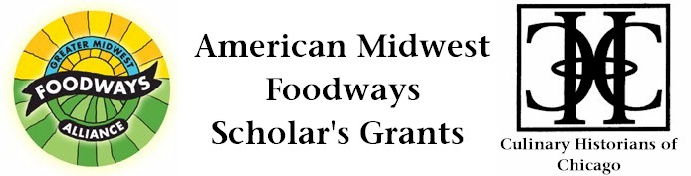
Stirring the Pot: The Story of Newspaper Food Journalism, Home Cooks & Ruth Ellen Church

Kimberly Voss
$500 Grant Award, 2013

In David Kamp’s history of American food, United States of Argula, women’s pages are largely dismissed – relegated to only a few mentions. In one reference, he refers to them as the “Jello-abusing women’s-page ladies” based on the bias of their simple sections. But these women actually played a significant role in the story of food in their communities and across the country. They helped home cooks balance their budgets while making good food. They shared recipes that defined communities and exposed readers to the dishes of new cultures. They also explained new nutrition discoveries and governmental regulations about food. Ruth Ellen Church was one of those female food editors who made a difference but has been left out of both journalism and culinary histories. This grant would help me tell her story.

Church was the food editor at the Chicago Tribune from 1936 to 1974. She usually wrote under the pen name “Mary Meade.” She became the country’s first newspaper wine editor in 1962. She also wrote many cookbooks on topics ranging from an anthology on pancakes to recipes for the blender.

Church graduated from Iowa State University in 1933 with a degree in home economics journalism. She briefly worked as a society reporter for a small Iowa newspaper before beginning a 38-year run as food editor at the Tribune – one of the first American newspapers to have a test kitchen. In the 1950s, the Tribune’s food section included a staff of 25 who Church oversaw. Church won six Vesta Awards – the top recognition for food sections. Little has been written about her long career in food journalism although there are a few references in recent books about food.

To tell Church’s story, I will examine her work at the Tribune and her papers at Iowa State University regarding her training in home economics journalism. In addition, I will order materials from the papers of Associated Press Food Editor Cecily who was a friend of Church. Brownstone amassed a collection of 8,000 cookbooks and hundreds of letters, which she donated New York University. This research establishes a place for Church and the value of the food sections in the annals of culinary history. It builds on the work of those who have examined materials like cookbooks to better understand the lives of women who are often left out of other historical accounts.

This scholarship would result in an article for publication in a culinary journal, such as Gastronomica, and also provide material for a book about food editors that I am writing for Rowman & Littlefield.

