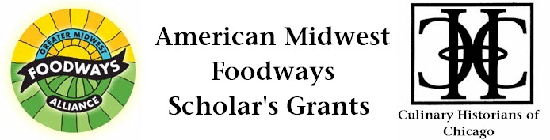
Political Appetites: Revolution, Taste, and Culinary Activism in the Early Republic

Nancy Siegel
Judging Committee’s Support, $500, 2013

This project, part of a book-length study, explores the creation and naming of recipes in American cookery books as an expression of nationalism and patriotic sentiment from the late eighteenth to the mid-nineteenth century. In particular, this study addresses the role played by women as culinary activists who, through their development of American recipes, furthered the causes of republican values as part of a domestic ideology. Thus, reading recipes as socio-political documents establishes a culinary discourse in the relationship between food and political culture as the rise in national identity from the late eighteenth through the nineteenth century coincided with a reappraisal of recipes in American cookbooks. The authors of such publications often titled their recipes to reflect this growing awareness. For example, Amelia Simmons, credited with writing the first American cookbook in 1796 (American Cookery) provided basic recipes for cakes. However, in a subsequent edition of her book from the same year, Simmons purposefully renamed her recipes with patriotic titles, thus a simple cake became the “Independence cake,” the “Election cake,” or the “Federal pan cake.” Although Simmons adapted many of her recipes from English cookbooks, it is in the naming of her recipes where the significance of cookery and patriotism overlap, thus linking language with food.

Recipes with political associations became plentiful throughout the early decades of the nineteenth century and I am seeking examples from the numerous cookbooks in which authors provided their own recipes for Election loaf cake, Federal cake, and Democratic tea cakes. These were celebratory recipes designed to feed large crowds and demonstrate that the social act of gathering to dine could be not only familial but patriotic as well. Such a nationalistic association with food allowed women to create a means to express their commitment to the new nation. In their own ways, these culinary activities codified and spread the themes of republican values in a cogent and material manner, thus firmly establishing its success in ways more powerful than presidential addresses or ratified documents ever could. I am also interested in finding recipes which hail the efforts of important political figures such as President cake, Washington fritters, Franklin buns, Madison cake, Lafayette gingerbread, and Jackson jumbles to name just a few. As the country grew stronger economically and politically, and expanded geographically, one finds that culinary patterns parallel this shift to regional distinctions with recipes for Kentucky sweet cake, Missouri cakes, Buckeye pudding, Wolverine junkets, and Hoosier cakes. The focus of this study is to examine not only recipes from cookery books, but also the personal journals and letters of women who wrote about their participation in nationalistic and patriotic celebrations and who copied recipes from family and friends in their receipt books and letters. The sheer number of different recipes with patriotic associations that were created demonstrates a segment of American culinary history that has been overlooked in scholarship. I posit that culinary history and American political theory are closely linked. By addressing the role of women as communicators of social and cultural mores, recipes named to instill American pride were forceful motivators in promoting a widespread involvement in the political arena. I am seeking funding to defray the cost of travel in support of research on cookbooks and women's history at the William L. Clements Library at the University of Michigan and at the Newberry Library in Chicago, Illinois.

