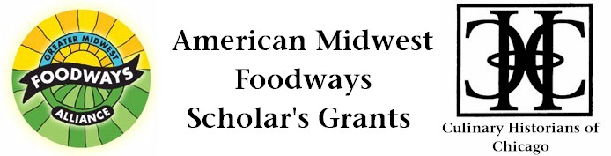
The Modenese Society Highland Park / Highwood, Illinois
Preserving Culinary Traditions for 100+ Years
Cibo è la Vita – Food is Life

Emma Kowalenko
Judging Committee’s Support, $500, 2013

The rich culinary traditions of Pievepelago, Santa Ana, and other small towns nestled in the mountains of Italy’s region of Emilia Romagna, continue to flourish at the Modenese Society, founded in 2006 in Highland Park / Highwood, Illinois.

The traditions of Befana and Cocetto during the Christmas and Easter holidays involve grandparent, grandchild, and everyone in between. This organization once reserved for men from the Modena area has expanded its membership to Italians from other parts of Italy, and a few years ago, to women. The festivals, fundraisers, monthly meetings, and social and family gatherings inevitably include food; savory and sweet, and Lambrusco wine, a specialty of the region.

The cakes are made just so, the cheeses robust, the deep fried pastries for Fat Tuesday shaped a certain way, with names to denote the shapes and origins. There is a historical memory for making a dish, a shape this way or that, roasting chestnuts just right, on a wooden fire, boiling and coloring 1200 eggs for Easter Morning; with brightly adorned children, and adults… tapping eggs all around to see whose egg remains uncracked the longest. The buzz, the hub bub of several hundred Modenese Society members gathered under one roof, linked by traditions of ancestors across the Atlantic denotes a piece of local, immigrant, American history that should be explored. So many questions beg to be answered.” Cibo,” food, its preparation, its origins, its enjoyment, will give us answers. As they say in this part of Italy, cibo è la vita, food is life, indeed!

What are these kitchens like, who are these cooks, who enjoys and eats these amazing meals, how did these recipes achieve such permanence on this new continent, how did this community’s culinary tradition stay as strong as it has for over 100 years?

This cross-generational, cross-cultural, oral history project will take us from kitchens to lavishly laid out tables in a church basement, in a renovated bocce club, in a park district banquet facility, in a home living room.

The life stories will be collected by younger people, in middle and high school, and college. Recipes will be demonstrated in cooking segments à la Julia Child, liberally sprinkled with Italian and the several dialects of the region. The videography will be coupled with a published book of life stories, photos, interwoven with recipes. The life stories will incorporate cooks, inspirations, and family members. It will be a priority to collect the perceptions of those who have been members for several decades. The full manuscripts of the oral histories will be transcribed and preserved in the local libraries. The book will include a DVD with the cooking demonstrations. A community event will be held to share the food, videography, and book.

