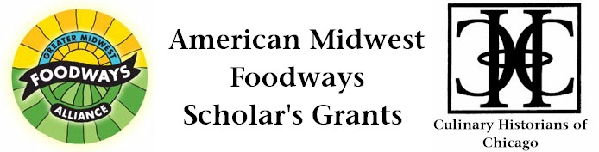
The Impact of American Indian Boarding School Education on
Great Lakes Indigenous Foodways

Amelia Katanski
$3,000 grant award, 2013

This project will explore the intersections of two of my areas of scholarship, teaching, and civic engagement: American Indian Studies (and, more particularly, the impact of Indian boarding schools on American Indian literary and cultural production) and food justice. I will examine the impact of the farming/agricultural component of the assimilative curriculum of late 19th/early 20th century Indian boarding schools on the foodways of Great Lakes American Indian communities.

While the earliest US national narratives involve American Indian people sharing access to and knowledge about food production on this land with European settlers (Squanto’s lesson about using fish to fertilize corn, squash, and beans; the first Thanksgiving), the US has a clear history of limiting tribes’ abilities to harvest, hunt, fish for, or access their traditional foods in order to assert control over Indian communities and advance national policy objectives. Indian boarding school education is one significant way federal actions actively worked to subvert native foodways. These schools purposefully separated Indian children from their tribal traditions as they taught literacy in English, Christianization, and vocational preparation for ownership of small, privately-owned plots of land. Students spent half of their time in the classroom and half working on the school farm, learning mainstream agricultural practices. Boarding schools were a significant component of Indian education from the late 1870s through WWII and coincided with allotment policy, in which tribally-owned reservation land was broken into homesteads intended to be owned by individuals and run as family farms, producing food that mirrored European-American dietary norms and supplanting endangered traditional foodways.

My previous work has focused on what took place inside the classrooms of Indian boarding schools, and I have published a book that traces the impact of boarding school education on the development of an English language American Indian literature. For this project, in contrast, I plan to turn to a close examination of the agricultural curriculum of the boarding schools and the way those lessons reverberated in the students’ home communities. Though the schools were designed to “Kill the Indian to save the man,” Indian students continually asserted intellectual sovereignty over the lessons they were taught at school—adopting, adapting, or discarding material to serve cultural, material, and community needs, and I will explore the ways they did this with their agricultural educations, even as school practices put traditional foodways at risk and compromised the health of native individuals and communities.

To complete this project, I will examine archival materials about school curricula and reports from agricultural field agents working on reservations in Minnesota, Wisconsin, and Michigan; I will read and analyze a range of personal narratives and letters written by former boarding school students and their families, and I will talk to American Indian people working toward maintaining and reviving indigenous foodways today. I will build on my knowledge of boarding school student narratives with archival work at the Chicago branch of the National Archives, which holds extensive records from the Great Lakes office of the Bureau of Indian Affairs, including information on reservation land use as well as regional Indian schools. I will also examine materials from the Edward E. Ayer collection at the Newberry Library (where I have been a fellow and a participant in a Lannan Summer Institute). I will also interview Native people involved in significant contemporary community foodways projects—at Native Harvest in White Earth, MN; Dream of Wild Health organic farm in Hugo, MN; Bad River Gitigaaning near Ashland, WI; and the Decolonizing Diet Project in Marquette, MI.

