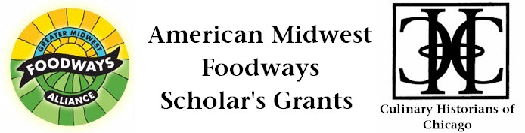
Fair-as-Foodway: Culinary Worlds and Modernizing Tastes at
Chicago’s 1893 World’s Columbian Exposition

Megan Edwards and Rebecca Graff
$1500 Grant Award, 2013

During the harsh winter of 1894, the Chicago Daily Tribune reported on the homeless who had taken refuge in the abandoned buildings of the World’s Columbian Exposition. Held for six months in 1893, the Fair hosted over 27 million visitors in a veritable city of over 200 buildings–replete with exhibits of art, living people, and consumables that modeled what the future promised for America’s citizenry at the turn of the 20th century. Yet within months of the Fair closing, so-called “tramps” would set up camp in the deserted buildings of the “White City,” eating the food and drink that had been left at the site. Many of the “imported delicacies” that these homeless salvaged from the ruins were the very “canned meat, sardines, prepared soups, choice pickles, wines of the most popular brands, and articles of confectionary” that had been exhibited in the Fair’s Agricultural Building (Chicago Daily Tribune 1894:1).

While the homeless of Gilded Age Chicago were driven by the economic hardships of the late 19th-century to scrounge what food they could from the detritus of Fair exhibits, formal visitors to the Fair would have had the opportunity, as their economic means allowed, to chose meals from over 35 restaurants. Offerings ranged from the more formal Cafe dé Marine, Swedish Restaurant, German Restaurant, New England Clam Bake, and Women’s Building Café; to smaller stands selling new products like Cracker Jack, Wrigley Juicy Fruit Gum, and Vienna Beef hot dogs. With bellies thus filled and taste buds thus titillated, visitors could tour exhibits– like those that filled the
Agricultural Building– showcasing familiar and exotic foodstuffs for their consideration as consumers.

The proposed project will build upon our previous research into the foodways of Chicago’s World’s Columbian Exposition to prepare an article-length piece for publication in a peer-reviewed journal. Through additional archival research, and further faunal analysis, we will explore the culinary worlds experienced at the Fair–worlds underpinned by the infrastructural and technological innovations of late 19th-century Chicago, home of the Union Stockyards. What’s more, the historical transformations that both facilitated the Fair, and were the focus of its exhibits, were experienced by an urban population that was itself dramatically transforming, as migrants from the rural United States and farther afield filled the burgeoning cityscape of Chicago, enabling the Fair’s very construction through their low-cost labor. The archaeological and archival record of the World’s Columbian Exposition can shed light on the foodways experienced by those who toured the Fair in 1893, providing a glimpse into the profoundly personal experience of what may otherwise come across as an episode of purely mass consumption. Found in scrapbooks, menus, advertising cards, exhibit designs, and in faunal remains from excavations, individual experiences of this 1890’s “Shock City,” channeled through the Fair’s “White City” foodways, provide access to how people encountered and responded to the traditions and novelty that they were faced with in negotiating modernizing urban food systems, where an international flow of materials and ideas met industrializing production chains.

