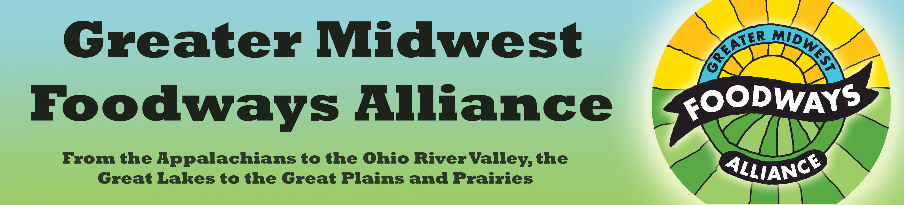

Tips for Selling at Printer’s Row

Selling books at Printer’s Row might seem like shooting fish in a barrel, but in reality, it’s more like trying to locate fish in the ocean. You know most of the folks at Printer’s Row are there because they’re interested in books. But there are also thousands upon thousands of books for sale. In that vast sea of printed pages, simply having a book doesn’t make you special. But that doesn’t mean you can’t draw people toward you and your book.

Best bets for grabbing the attention of potential buyers:

Have a sign that shows your book cover or says something about your book. It doesn’t have to be big: 8-1/2 x 11” is fine.

When people come by, be sure to be standing up. Standing in front of the table is good, as it removes the barrier. It also makes it harder for people to just walk by.

Greet browsers, or even passersby who look your way, and ask if they are interested in something related to your book.

If you’re at the Greater Midwest Foodways Alliance table, be sure to point out the Alliance and say a few words about it and its purpose, then establish that you are part of this great organization. That helps the GMFA, but it also makes you more credible—you’re not just someone with a book; you’re someone who is part of a greater entity (an organization made impressive by your enthusiasm for it).

Have a 15-second speech for anyone who glances your way. Then have a 1-minute speech ready if anyone picks up your book.

Remember that selling is not passive—you need to show that you care about the customer and about your subject matter.

It doesn’t matter how good your book is if you can’t grab folks’ attention. Like Michelangelo said, “You’re a genius if you can sell it.”

Cynthia Clampitt
http://www.worldplate.com

